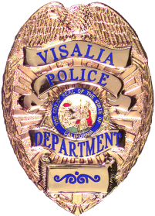ssg

VISALIA POLICE DEPARTMENT
Jason Salazar, Chief of Police

Sergeant Damon Maurice, Public Information Officer
(559) 713-4216 (office) / (559) 713-4807 (fax)
damon.maurice@visalia.city

***NEWS RELEASE***
July 31, 2026

VPD Report Number: N/A | Date/Time Occurred: 5/8/17 1200-1600 Hrs
Type of Incident: Alcoholic Beverage Control  IMPACT Inspections | Location: ABC licensed establishments throughout Visalia

Name of Business (if applicable):

Suspect: | Age: | Arrested:
1.
2.
3.

Details: On May 8, 2017, between the hours of 12 p.m. and 4 p.m., Visalia Police Officers conducted multiple "Informed Merchants Preventing Alcohol-Related Crime Tendencies" (IMPACT) inspections at ABC licensed establishments around the city. During the inspections, IMPACT teams select and survey licensed outlets at random. During the visits, IMPACT teams remind licensees of the responsibilities and accountability associated with the sale of alcohol. The officers also inspect licensed premises for compliance with State laws. Although the focus is to educate, officers will take action if they see any major violations during the inspections. During this detail, only minor administrative violations were discovered. The businesses were advised and educated on the violations and will be given an opportunity to correct them. The IMPACT team will revisit those businesses in the near future to confirm compliance. Funding for this program was provided by a grant from the California Alcoholic Beverage Control (ABC) through the department’s Grant Assistance Program. ABC is a Department of the Business, Consumer Services and Housing Agency.

Arresting / Investigating Officer: VPD Officers | Supervisor: Sergeant C. Jennings

