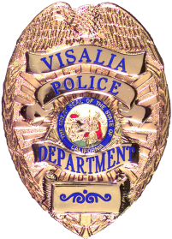ssg

VISALIA POLICE DEPARTMENT
Jason Salazar, Chief of Police

Sergeant Damon Maurice, Public Information Officer
(559) 713-4216 (office) / (559) 713-4807 (fax)
damon.maurice@visalia.city

***NEWS RELEASE***
July 29, 2026

VPD Report Number: 17-28413 | Date/Time Occurred: 4-11-17 / 2030 hrs.
Type of Incident: Shooting at an unoccupied vehicle | Location: Visalia Sports Park  3600 Block N. Dinuba

Name of Business (if applicable):

Suspect: | Age: | Arrested:
1. Unknown |  | No
2.
3.

Details: On Tuesday, 4-11-17 at approximately 2030 hours, officers responded to the Visalia Sports Park located on the 3600 Block of N. Dinuba Boulevard regarding a report of shots fired. Officers contacted an adult female who reported an unkown suspect pulled up in a 90's model, green or turquios colored SUV and fired at least twice from a firearm, striking the left/front area of her parked vehicle, before fleeing. There were no injuries. Should anyone have any information regarding this incident, they are urged to contact the Violent Crimes Unit at 713-4234.

Arresting / Investigating Officer: Patrol | Supervisor: Sgt. Chris Jennings

